**SCD workshop assignment:**

DDL scripts for  
a. etl_job

'etl_job', 'CREATE TABLE `etl_job` (\n `job_id` int NOT NULL AUTO_INCREMENT,\n `job_name` varchar(50) DEFAULT NULL,\n `table_name` varchar(32) DEFAULT NULL,\n `schedule` varchar(20) DEFAULT NULL,\n `created_by` varchar(20) DEFAULT NULL,\n `created_date` datetime DEFAULT NULL,\n PRIMARY KEY (`job_id`)\n) ENGINE=MyISAM AUTO_INCREMENT=28 DEFAULT CHARSET=utf8mb4 COLLATE=utf8mb4_0900_ai_ci'

b. etl_job_log

'etl_job_log', 'CREATE TABLE `etl_job_log` (\n `job_log_id` int NOT NULL AUTO_INCREMENT,\n `job_id` int NOT NULL,\n `job_status` varchar(20) DEFAULT NULL,\n `created_by` varchar(20) DEFAULT NULL,\n `created_date` datetime DEFAULT NULL,\n PRIMARY KEY (`job_log_id`)\n) ENGINE=MyISAM AUTO_INCREMENT=7 DEFAULT CHARSET=utf8mb4 COLLATE=utf8mb4_0900_ai_ci'

c. ProductPriceHistorySCD table

'productpricehistoryscd', 'CREATE TABLE `productpricehistoryscd` (\n `SCD_SK` int NOT NULL AUTO_INCREMENT,\n `ProductID` int NOT NULL,\n `ProductName` varchar(50) DEFAULT NULL,\n `ListPrice` decimal(19,4) DEFAULT NULL,\n `scd_start` date DEFAULT NULL,\n `scd_end` date DEFAULT NULL,\n `scd_version` int DEFAULT NULL,\n `scd_active` int DEFAULT NULL,\n `DI_JobId` varchar(20) DEFAULT NULL,\n `DI_CreateDate` date DEFAULT NULL,\n PRIMARY KEY (`SCD_SK`)\n) ENGINE=InnoDB AUTO_INCREMENT=1261 DEFAULT CHARSET=utf8mb4 COLLATE=utf8mb4_0900_ai_ci'

d. ProductCostHistorySCD table

'productcosthistoryscd', 'CREATE TABLE `productcosthistoryscd` (\n `SCD_SK` int NOT NULL AUTO_INCREMENT,\n `ProductID` int DEFAULT NULL,\n `ProductName` varchar(50) DEFAULT NULL,\n `StandardCost` decimal(19,4) DEFAULT NULL,\n `scd_start` date DEFAULT NULL,\n `scd_end` date DEFAULT NULL,\n `scd_version` int DEFAULT NULL,\n `scd_active` int DEFAULT NULL,\n `DI_JobId` varchar(20) DEFAULT NULL,\n `DI_CreateDate` date DEFAULT NULL,\n PRIMARY KEY (`SCD_SK`)\n) ENGINE=InnoDB DEFAULT CHARSET=utf8mb4 COLLATE=utf8mb4_0900_ai_ci'

ALTER TABLE etl_job_log

ADD CONSTRAINT fk_job_id

FOREIGN KEY (job_id)

REFERENCES etl_job(job_id);

**Talend Jobs Screenshots:**

**Aw_LOad_Product_Cost_History**

**Aw_Load_Product_Price_History**

**Sort ProductCostHistory**

**Sort ProductPriceHistory**

**Pre Job Log**

**Post Job Log**

**Main Orchestration:**

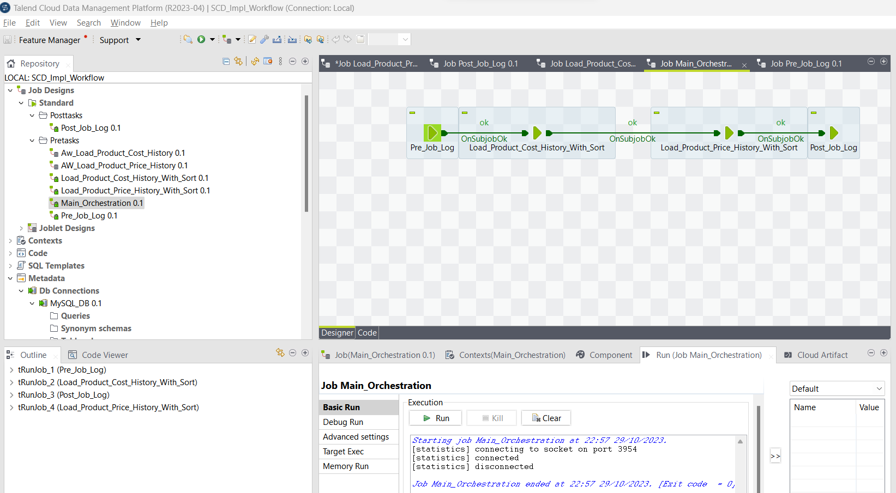

5. Screenshot of all tables' data in the database after the talend job run

**Productcosthistoryscd:**

Etl_job_log

**productpricehistoryscd**

**etl_job**

